**Report:7**

**Date: 6th April to 12th April 2025**

**Group-1**

**Project Title: Hard stop and momentary stop using vehicle trajectory dataset**

**Target: Filtering vehicles, Identifying and Removing hardstop , Splitting upper and lower signal data ,Applying change point detection and comparing with ground truth**

**Team Members:**

|  |  |
| --- | --- |
| Aarsha shah | AU2240163 |
| Hetav shah | AU2240253 |
| Ved Savalia | AU2240242 |
| Parshwa shah | AU2240249 |
| Dev Gorakhiya | AU2240087 |

## **Introduction**

This report details the progress made in Week 7 of our project. In this report, we have focused on filtering and removing hardstop. Then for momentary stop, we have splitted upper and lower signal to have detailed analysis. Further we have applied change point detection on individual signals to identify window size for making clusters in temporal analysis. After applying the algorithm we have compared with ground truth value.

**Filtering**

Tracks with limited data points often represent noisy or incomplete data that may not be a vehicle’s actual behaviour. So to have meaningful and consistent analysis of a trackid, we began by filtering out vehicle trackIDs where frames are less than 100. Hence we are left with trackIDs with sufficient frames to analyse its behaviour.

**Removing Hardstop**

Hardstop is when the velocity immediately drops to near zero after a high negative jerk. These events can skew the analysis of momentary stops and subtle driving behaviour. Therefore we identified and removed hardstop segments from the data. We removed the trackID row where average velocity drops to zero.

**Splitted Upper and Lower signal**

To perform a detailed analysis of vehicle motion behaviour, we have separated the movement into two distinct directional components:

* Upper signal - The signal that has vertical movement.

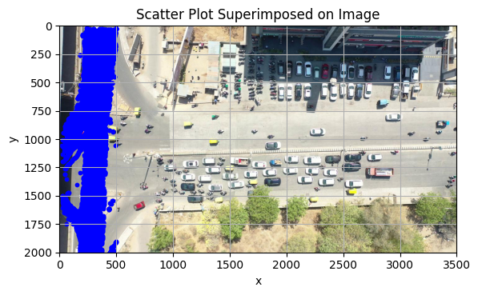

* Lower signal - The signal that has horizontal movement.

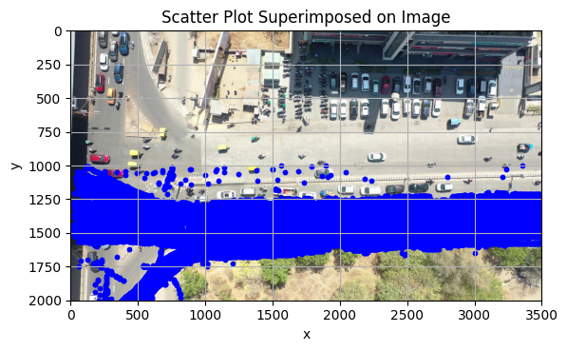

**Change point detection (CPD)**

We have detected significant behavioral transitions in vehicle motion by Change Point Detection to the jerk signal. We have smoothened the jerk signal using moving average to reduce noise and make subtle transitions more detectable. Pelt algorithm is applied to smothered jerk signals to identify points where jerk of signal shifts noticeably. This CPD algorithm is applied on both lower and upper signals. These transitions show meaningful changes in vehicle’s behaviour. In order to identify momentary stops, local minima and maxima values of jerk values are identified using CPD algorithm.We have also identified vehicles which have extreme jerk values.

**Future Work**

1. Once local minima and maxima are identified for each track id, we will group them into one window with respect to frame range.
2. Then we will make a cluster and superimpose it on the main video file.